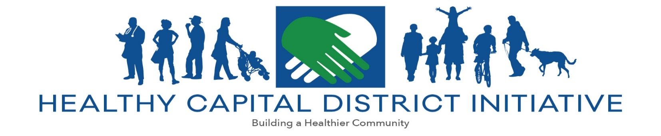

Technical Assistance Request

HCDI provides technical assistance for the development of population health initiatives. Services include: (1) health data collection and analysis; (2) community health needs clarification; (3) research of evidence-based and promising practices; (4) support for the advancement of prioritized public health initiatives; (5) program evaluation. Technical assistance must be consistent with the Population Health Improvement Program work plan and advance the New York State Prevention Agenda, the State Health Innovation Plan, or the Delivery System Reform Incentive Program.

Partner
Date of Agreement
Partner Organization

Project Specifics
Project Title
HCDI Project Lead
Partner Project Lead

PHIP Scope of Work
Activity | Description
 | Deliverable 1 |  | Due Date
 | Deliverable 2 |  | Due Date
 | Deliverable 3 |  | Due Date
How will this activity contribute to the partner’s Population Health objective?
*Reasonable notice shall be given if deliverables and/or deliverable deadlines require amending by either party.

HCDI  Executive Director |  |  | Date |  | Partner Representative |  |  | Date

Please email completed form to Dr. Kevin Jobin-Davis at: kjobin-davis@hcdiny.org

